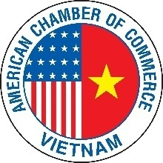

Ho Chi Minh City

-------------

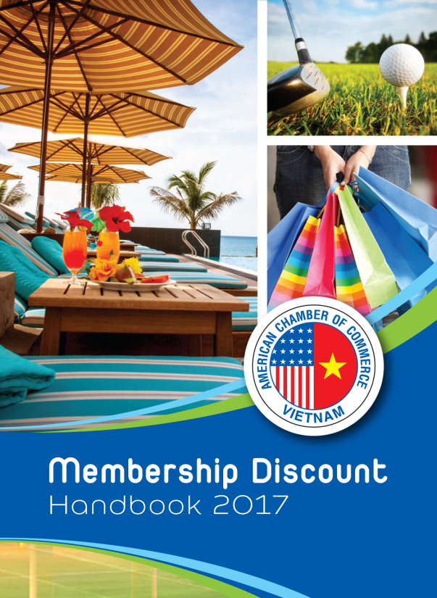
2017 AmCham HCMC Discount Handbook

ADVERTISING BOOKING FORM

Advertising space / Position | Size (cm)  (width x height) | Rate  (VND) | Order ‘X’
Back cover | 8 x 11.5 | 9,000,000
Inside front cover | 8 x 11.5 | 7,000,000
Inside back cover | 8 x 11.5 | 7,000,000
Inside front right | 8 x 11.5 | 7,000,000
Inside back left | 8 x 11.5 | 7,000,000
Inside (full page) | 8 x 11.5 | 5,000,000
*** No red invoice issued as AmCham is a not-for-profit organization.

We would like to book the advertisement in 2017 AmCham Discount Handbook:

Company Name:____________________________________________________________________
Approved by: Name (Mr/Ms): ________________________________________________________________
Position: _______________________________________ Email: ________________________________________
Contact Person: Name (Mr/Ms): ____________________________________________________________
Position: ______________________________________ Tel/Mob: _______________________________________
Email: _______________________________________________________________________________________
Notes:

- Circulation: 1,300 copies
- Release: Jan 2017
- Binding by staples
- Layout should be sent by November 30, 2016.
- Ads will be reserved but not confirmed until payment is received in full. If payment is not received by November 30, 2016, your booking will no longer be held.

Payment Options:
In cash at the AmCham Ho Chi Minh City Office
By Wire transfer to Citi Bank, 115 Nguyen Hue, District 1, HCMC
Acc Name: “AmCham Ho Chi Minh” Acc No: 0-300044-093
By Credit Card: Visa Master Amex
Credit card No.: ________________________________ Exp. Date (MM/YY) ______/______
Name on Card: ________________________Signature - required: ____________________

