2017 AmCham HCMC Discount Program

The AmCham Discount Program encourages over 1,000 members who are representatives of high profile companies and U.S. Consulate staffs to consider when making buying decisions.

What type of discounts can be offered?
  - Any! Some that could be offered include a percentage off the purchase price.
  - Be creative! You may want to keep in mind that to be effective and popular, the discount or bonus should be substantial enough to attract attention.

What are the guidelines?

- Discount must be an exclusive discount/promotion to Chamber members, over and above what non-members would receive.
- The participant agrees to abide by their discount/promotion and fully understands that it is their responsibility to notify the Chamber of any and all changes immediately.
- The participants agree to educate employees about the AmCham Discount Program and display the AmCham Discount signage at their venue, indicating their participation in the program.

Tips for success:
    - Educate your employees. Utilize the Program description sheet to inform your employees about the AmCham Discount Program. Place this information in a break room or common area that employees share.
    - Track your results. If possible, record the number of discounts issued per month to measure the business traffic of AmCham members. Chamber staff will also utilize this information each month to monitor the success of the program.
    - Market your business. By displaying the AmCham Discount signage at your points of sale, AmCham members will know that you are a participating business in the discount program.

If you would like to participate, submit the below application.

Member Card sample:

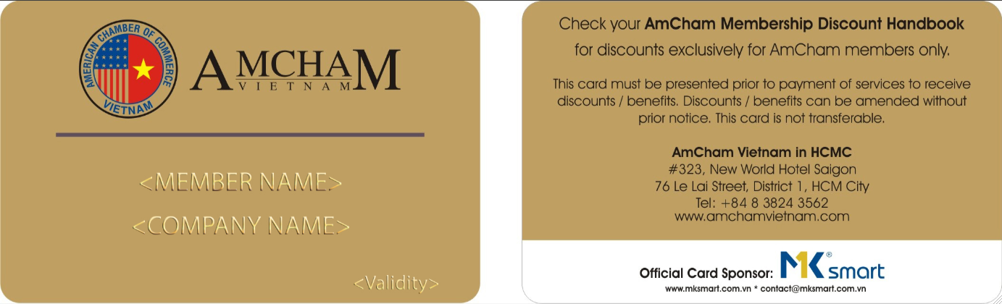
Representative: Mr. Herb Cochran, Executive Director
Contact Person: Ms. Sam Hoang, Membership Services Executive
Ms. Han Nguyen, Membership Services Assistant

2017 Participation Form

Company Name:

Address:

Telephone: ________________________ Website: __________________________________

We hereby to confirm to offer to AmCham members as follows: (Please provide percentage of discounts for your products and/or services)
Ganh Restaurant  • 58/4 Pham Ngoc Thach St., Dist. 3  Tel: (08) 3829 5243  SAMPLE  • Vincom A, B3 Floor  171 Dong Khoi St., Dist. 1  Tel: (08) 3936 9599  www.nemnuongganh.com  10% off on bill | <Name>_______________________________  <Add>________________________________  <Tel>_________________________________  <Web>________________________________  <Offer>_______________________________

Please send us _____ signage(s) for displaying at the counter to:
Name & Address: ________________________________________________________________________________
_______________________________________________________________________________________________

Validity: January 1, 2017 - January 31, 2018
_____________________________

Terms and conditions:
You must ensure that your staff (1) be well aware of the AmCham Discount Program, (2) accept a valid AmCham Membership Card to qualify for the discount(s) and/or benefit(s) your company is/are offering, and (3) display the AmCham Discount signage in a prominent place at your venue. Failure to fulfil these obligations will result the termination of your Discount Program with AmCham.

I accept the terms and conditions of registration.

Date: ………………. Approved by: Name (Mr/Ms): ___________________________________________
Position: ___________________________ Email: __________________________________________________

Contact Person: Name (Mr/Ms): ___________________________________________
Position: ___________________________ Email: __________________________________________________

*** AmCham would appreciate your reply to these following questions:

- How many AmCham members have visited your venue in 2016: _______________Persons
- How much AmCham members have spent at your venue in 2016: _____________VND/USD
Thank you for your support. Please kindly keep track this record in 2017 for surveying.

