Hanoi, 12th August 2019

Subject: Introducing Make in Vietnam Energy Plan (2.0)

Dear AmCham Viet Nam, HCMC Chapter

For and on behalf of the Vietnam Business Forum (“VBF”) Consortium and VBF Power & Energy Working Group (WG), we would like to present the best compliments to…

Vietnam Business Forum was established in 1997 during the annual Consultative Group meeting between the Government of Vietnam and its donor partners and has been served as an on-going policy dialogue between the Government and business communities towards developing a favourable business environment, attracting private investment, and enhancing the sustainable economic development in Vietnam.
The Sustainable Energy Engagement Project under the VBF Power & Energy WG is being implemented within 2019 to enhance the involvement of the private sectors in sustainable energy development in Vietnam.

In that context, the Make in Vietnam Energy Plan (MVEP 2.0) provides extensive updates and revisions as information regarding government policies and research funded by foreign donors became available, which is based on Make in Vietnam Energy Plan (MVEP 1.0), 2016 version. This report also reflexes Vietnam’s rapidly changing energy context.

The Make in Vietnam Energy Plan (MVEP 2.0) was prepared through a collective effort representing the concerns, experience and interests of members of the Vietnam Business Forum, a consultative group whose members and affiliates include 14 foreign and domestic chambers of commerce.

This report is expected to become a useful reference for Vietnam's energy sector as well as for electricity and energy planning policies in the coming time.

Power and Energy Working Group kindly sends a copy to AmCham HCMC of the Make in Vietnam Energy Plan (MVEP 2.0) and hopes to receive comments from you.

Sincerely,
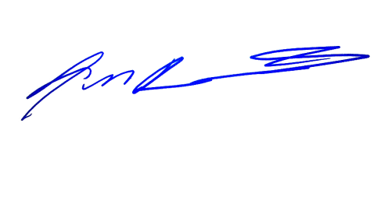  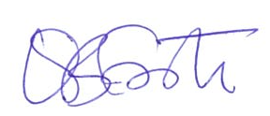  Virginia Foote  Co-Chair  Vietnam Business Forum | John Rockhold  Head of Power & Energy WG  Vietnam Business Forum

For any enquiry, please kindly contact: Mr. Luong Ba Hung, Project Director, VBF Power and Energy Working group, Tel: 0902 177 123, Email: luong.ba.hung.wec@gmail.com; and/or VBF Secretariat, Tel.:024 3715 2223, Email: info@vbf.org.vn

The Vietnam Business Forum Consortium is led by Vietnam Chamber of Commerce and Industry (VCCI), American Chamber of Commerce in Vietnam (AmCham), European Chamber of Commerce in Vietnam (EuroCham), Korea Chamber of Commerce in Vietnam (KoCham), Japan Business Association in Vietnam (JCCI), and British Business Group in Vietnam (BBGV). There are 09 other business organizations and chambers of commerce who participate in the Consortium as Associate Members, namely: AusCham, CanCham, HKBAV, InCham, SBA, SBG, CTCVN, Hanoi BA, TBA. VBF’s activities are mainly carried out through high profile bi-annual Forums between the business community and high level Government leaders and through on-going activities of specialized Working Groups (“WGs”) cutting across sectors: Banking, Capital Markets, Tax, Customs, Investment & Trade, Land, Education & Training, HR, Agriculture, Infrastructure, Power & Energy, Port & Shipping, Mining, Automotive, Tourism, and Government & Integrity. After 20 years since its establishment, VBF has been strongly developed both in terms of membership, activities and reputation. The VBF bi-annual forums frequently receive a high attention by Government Agencies, businesses, local & foreign chambers, diplomatic missions and well known international organizations in Vietnam and press.

