VIETNAM HR AWARDS GALA 2020:
10+ REAL SUCCESS STORIES FROM THE AWARD-WINNING COMPANIES
The award ceremony of Vietnam HR Awards 2020 will bring insightful perspectives of more than 10 C-suite speakers and top responsive companies which win the unplanned of Covid-19. .
For the very first time, at Vietnam HR Awards Gala 2020 – Special Edition, participating attendees will have the exclusive opportunity to listen and learn from real case studies and practical lessons from winning companies about their responsive HR strategies in 2020. This is the first time those award-winning businesses share their success stories in using HR strategies to confront the crisis, particularly in the “new normal” time after Covid-19.
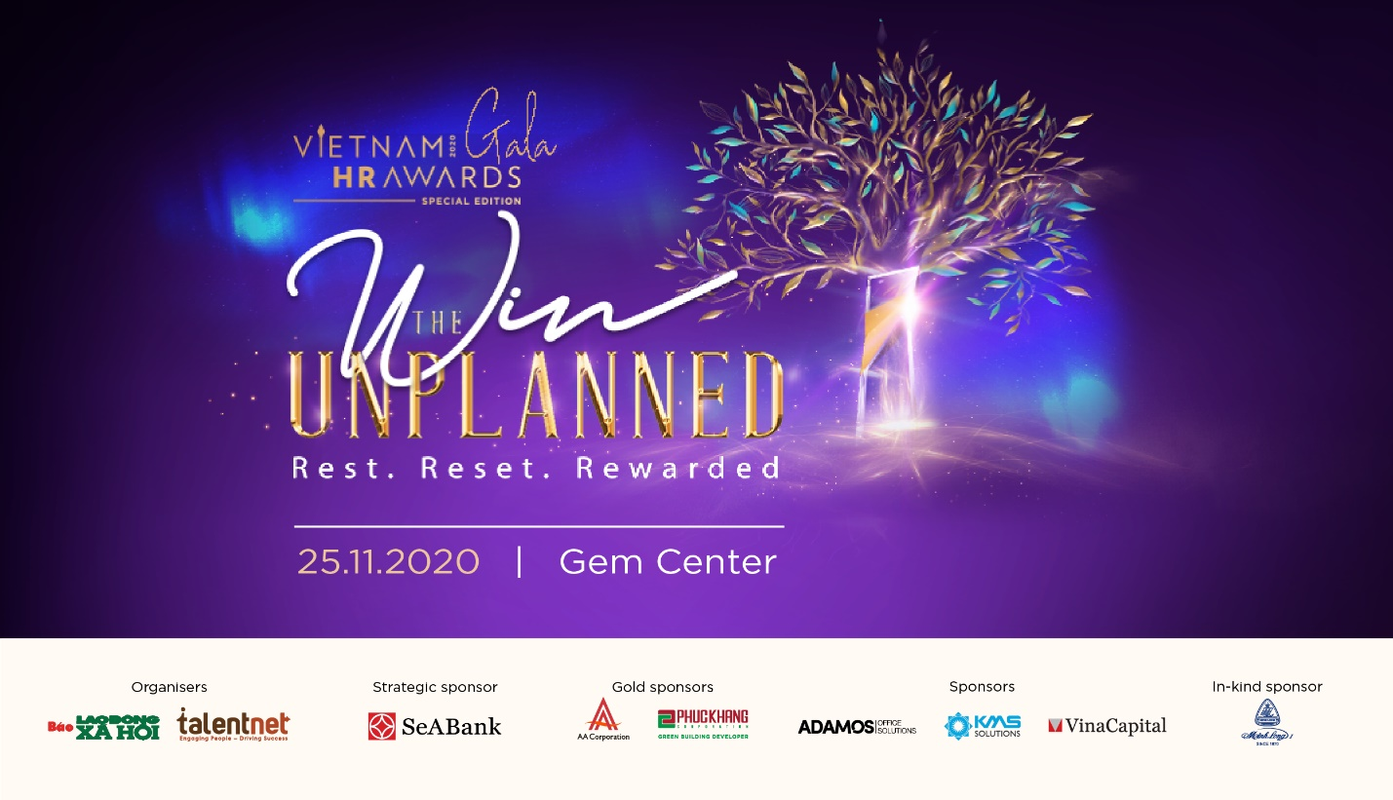
Moreover, Vietnam HR Awards Gala 2020 with the theme “Win the unplanned” will bring up thought-provoking discussions between representatives of the Government and top-notch leaders of businesses, about the topics:
- Vietnam – The snapshot of measures in response to Covid-19: lessons learned about the collaboration between policymakers and enterprises, exemplary measures from other ASEAN countries,…
- Business immunity – Gaining back the stability: the new normal of business mission towards its employees and communities, the success responsive initiatives, lessons learned for more sustainable growth,…
- Reset people agenda with estimated success: the revolutionary approach in business and people agenda, new set of values and standards of leaders and talents,…
Vietnam HR Awards Gala 2020 will take place on November 25, 2020, at GEM Center, with the key spirit of “3R - Rest, Reset & Rewarded”, promising to bring a completely different experience for attendees.
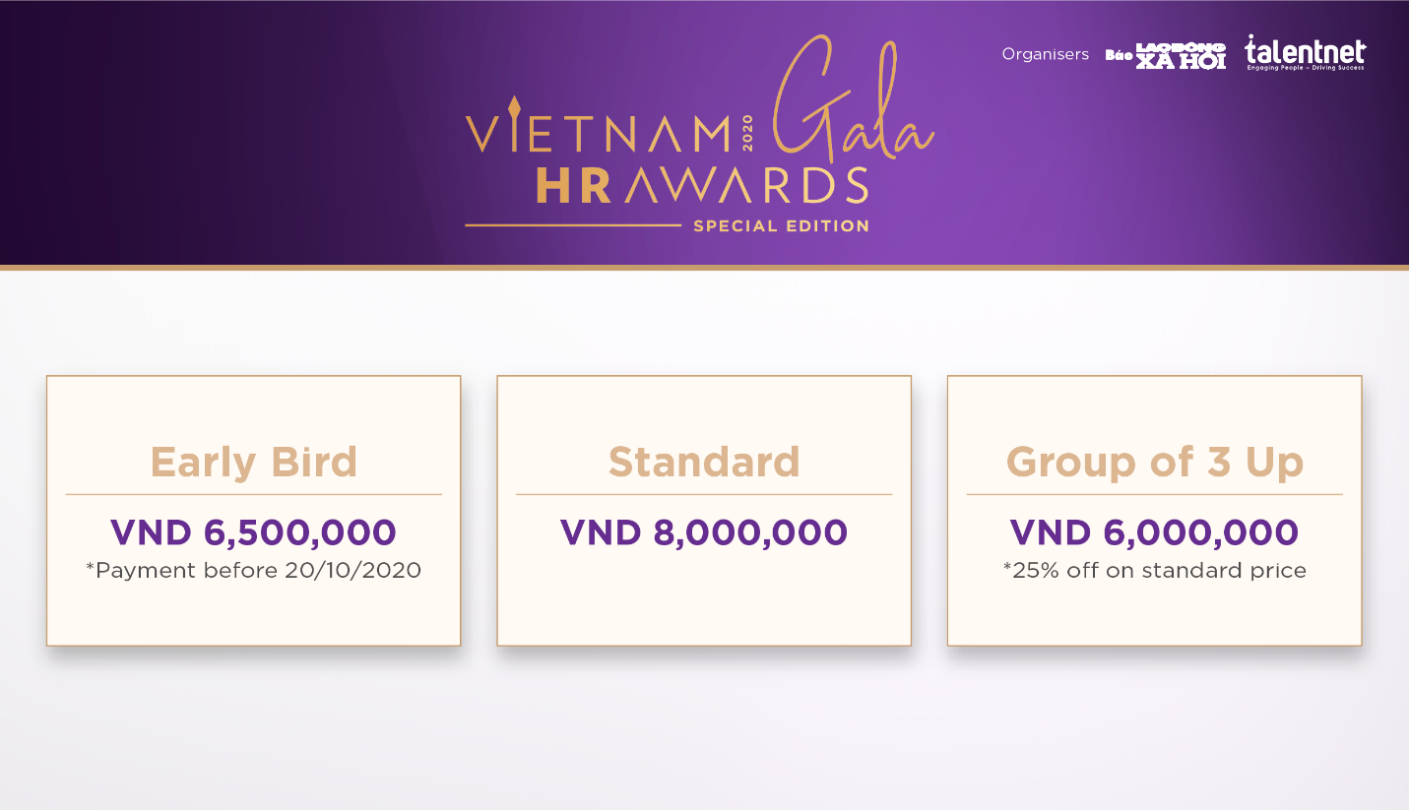
The Awards is organized by The Labour & Social Affairs newspaper & Talentnet Corpqoration, with the sponsorship of SeaBank, AA Corporation, Phúc Khang, Adamos, KMS Solutions, VinaCapital and Minh Long.
Promotion on ticket sales!
The tickets to attend the Vietnam HR Awards 2020 Gala Ceremony are now on sales with early bird price at VND 6,500,000/ticket for payment before October 20, 2020.
For group buying from 3 tickets up, the price would be at VND 6,000,000/ ticket (discount 25% on standard price VND 8,000,000).
More event information and ticket purchase: https://bit.ly/2F9nYaP

